Organisation Overview
Name: Johannesburg SPCA (Society for the Prevention of Cruelty to Animals)
Background:
The Johannesburg SPCA has a long history of promoting animal welfare in South Africa. It provides shelter, adoption services, and veterinary care for abandoned, abused, and neglected animals.
Mission: To prevent cruelty to animals and provide shelter, care, and adoption opportunities for animals in need.
Vision: A community where every animal is treated with compassion and has the opportunity to live a safe, healthy life.
Target Audience:
- Individuals and families interested in adopting pets
- Donors and sponsors supporting animal welfare
- Volunteers and community members looking to get involved
- General public seeking information on animal welfare

2. Website Goals & KPIs
Purpose of the site:
- Improve community engagement and awareness.
- Increase the number of pet adoptions.
- Drive donations and volunteer sign-ups.
- Share success stories and educate the public on animal welfare.
Key Performance Indicators (KPIs):
- Website traffic growth (visitors/month).
- Number of completed adoptions through the site.
- Online donation volume.
- Volunteer sign-ups via online forms.
- Social media shares and blog readership.

3. Current Website Analysis
Strengths:
- Provides basic information on services.
- Recognized and trusted organization.
Weaknesses:
- Outdated design with limited emotional appeal.
- Navigation is cluttered and confusing.
- Not mobile-friendly.
- Lack of compelling imagery.
- Weak calls-to-action (adopt/donate not highlighted).
Improvements Needed:
- Modern, responsive design.
- Streamlined navigation and content flow.
- High-quality visuals to evoke empathy and engagement.
- Clear, visible calls-to-action.

4. Proposed Features
- Homepage: Hero banner with adoption/donation CTAs.
- Adoption Page: Searchable gallery of adoptable pets with profiles.
- Donation & Volunteer Forms: Integrated, user-friendly submission forms.
- Blog/News Section: Updates on events, success stories, and animal welfare.
- Contact Page: Interactive map, FAQs, and contact form.
- Mobile Responsiveness: Optimized for smartphones and tablets.

5. Design & UX
Colour Scheme: Warm, compassionate palette – soft greens, warm oranges, and neutral greys.
Fonts: Friendly, approachable sans-serif (e.g., Poppins, Nunito).
Layout Ideas:
- Grid layout for adoptable pets.
- Card-style news/blog entries with visuals.
- Sticky navigation bar with quick access to “Adopt,” “Donate,” “Volunteer.”
- Full-width hero image with call-to-action button.
Wireframes (concept):
- Homepage: Hero image + three key CTAs (Adopt, Donate, Volunteer).
- Adoption Page: Grid gallery with filters (Dogs, Cats, Other).
- Blog/News: Simple vertical list with image + short text snippet.

6. Technical Requirements
- Hosting: Shared hosting (R50 – R100/month).
- Domain: .co.za domain (R100 – R150/year).
- Technologies:
  - WordPress (for CMS flexibility) OR HTML/CSS/JS (custom build).
  - Form integrations (Google Forms or WP plugins).
  - Free visual resources (Unsplash, Pexels, FontAwesome).

7. Timeline & Milestones
Week | Task
1 | Research organization & gather content
2 | Plan structure and create wireframes
3 | Design homepage and adoption page
4 | Build donation and contact sections
5 | Testing & mobile responsiveness
6 | Final review and project submission

8. Budget
 | Description | Estimated Cost (ZAR)
Domain Name | Optional (.co.za) | R100 – R150/year
Hosting | Entry-level shared hosting | R50 – R100/month
Design Tools | Free tools (Figma, Canva) | R0
Development | Student project (no cost) | R0
Total: Approx. R150 – R250

9. References
- Johannesburg SPCA official website: https://jhbspca.co.za
- Unsplash & Pexels (for royalty-free images)
- Web design best practices (Nielsen Norman Group)
- Animal welfare and adoption website examples (ASPCA, RSPCA)

Pictures I’ll be using :

Logo of the business :

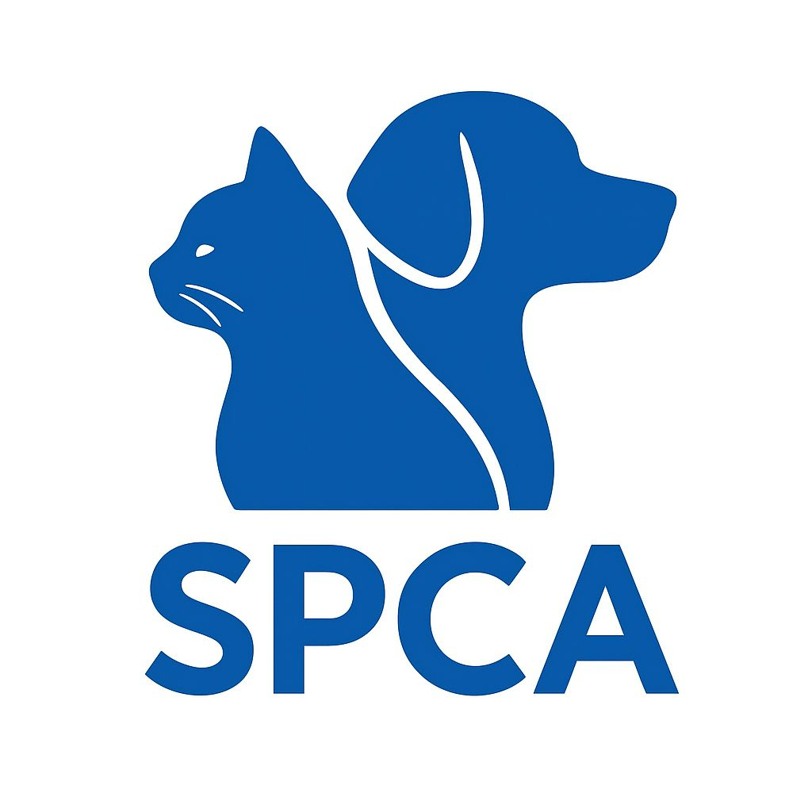

Pictures of the animals :









Volunteers:

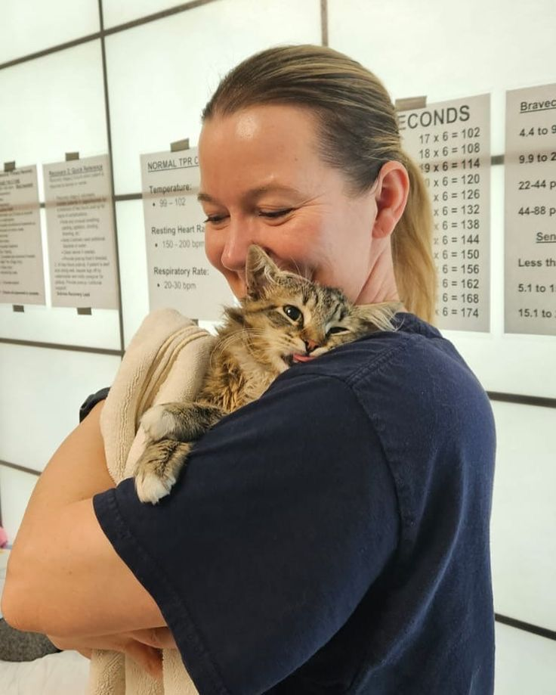

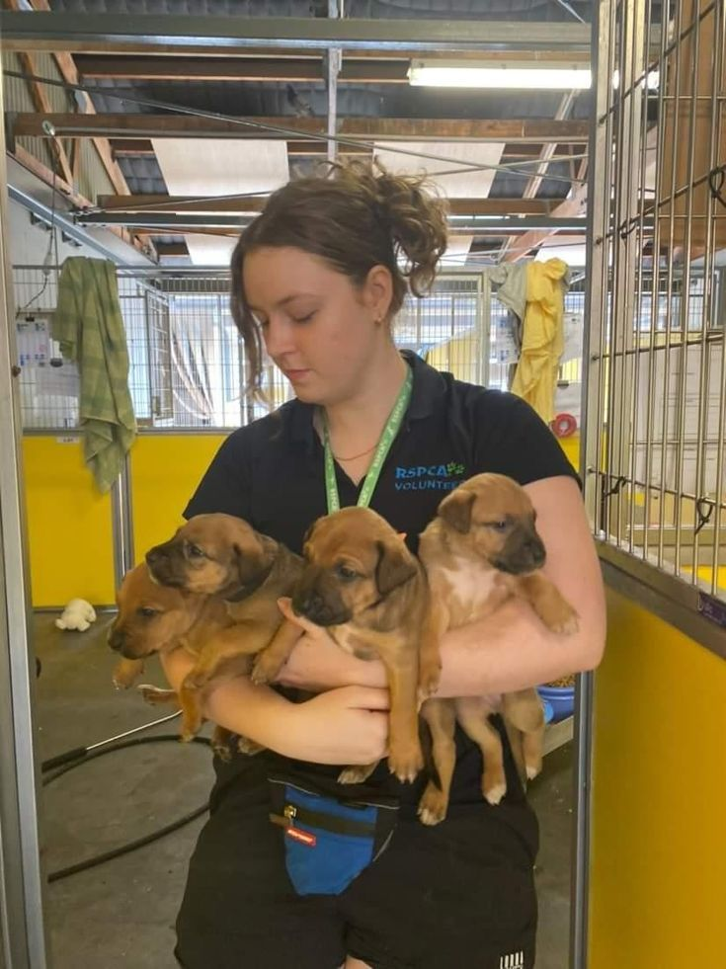

Homepage picture :



Contact picture:



